STINGER 41 DECORATIONS BOARD REBUTTAL 8-11-2025
(bold are excerpts from results memo, non-bold are our rebuttals)
1. “When the Board considered the original submission for the Stinger 41 crew, it was precluded from obtaining the customary written advisory from the Air Force Historical Research Agency (AFHRA) due to the proponent’s emphatic request for rapid adjudication in time for the 50th Anniversary Commemoration of the events under review.”
This assertion wrongly shifts responsibility onto the proponents, implying they caused the Board’s lack of preparation. This is not accurate.
The AC-119 Gunship Association and former SECAF Whitten Peters were the original proponents. In December 2021, the Association provided two potential presentation dates: 2 May 2022 and 2 October 2022. Senator Mark Kelly, then designated presenter, chose 2 May.
Later, AFSOC assumed the role of presenter and requested the rapid adjudication. It was AFSOC’s command staff—not the Gunship Association—who scripted the event, demanded status updates from AFPC, and pushed for a firm adjudication deadline. They even stated in writing that they would “keep the heat on” to ensure timely completion.^{1, 2}
According to SAF/MRBP, the Decorations Board was given only nine days to prepare, while AFPC later admitted that normal preparation takes four to six months. Convening the Board under these conditions was fundamentally flawed and unjustified. The result was a rushed and incomplete process.³
The inadequate timeline caused:
- No time for AFHRA advisory input³
- No time for comparison with similar combat award precedents
- No time for full personnel files from NPRC³
A second presentation date—2 October 2022—was available the entire time. The rush was unnecessary and entirely avoidable.

2. “The analysis focused on the three primary affidavits… the Board concluded these actions did not meet the criteria for the Silver Star Medal, DFC, or AM.”
The Board’s conclusion—denying awards to seven of the nine crew members—is a profound miscarriage of justice.
The Stinger 41 crew flew a rare daylight mission into An Loc, the most heavily defended city in South Vietnam, in a night-designed aircraft painted black, making them highly vulnerable to enemy fire. Despite intense AAA, the crew made multiple attack passes to destroy a high-value target. They were eventually shot down—three KIA, seven survivors.^{9, 12, 13, 15}
A U.S. Senator, a former Secretary of the Air Force, 24 General Officers (including four Chiefs of Staff), the wartime Wing and Squadron Commanders, and the AFSOC Commander all independently assessed that the crew’s actions clearly met the criteria for valor awards.⁴
The SAR mission commander also confirmed that the crew's heroic actions on the ground directly contributed to their rescue and survival.⁵
The Board’s dismissal of these actions reflects a failure to grasp the operational context, the extreme risk, and the overwhelming evidence of gallantry.

3. “Former Secretary of the Air Force, the Honorable F. Whitten Peters, requested reconsideration… the package included an unofficial 7-page summary [unknown author] of An Loc operations.”
This statement is inaccurate and misleading.
The An Loc summary was an official, integral part of SECAF Peters’ signed reconsideration package. It was submitted as Attachment 2. It is disingenuous to refer to it as an “unofficial” summary by an “unknown author.” The source was known, the content was heavily documented, and it was submitted through proper channels.⁶

4. “...it is more likely than not the entire crew of Stinger 41 was duly considered for recognition in real time. Specifically, military personnel records indicate six members of the crew received AMs, where the award period included the events of May 2, 1972. Two crew members were each awarded the DFC, one for a mission on April 30, 1972, the other for a mission on May 1, 1972. Additionally, all ten Stinger 41 crewmembers were awarded Purple Hearts for injuries sustained on the May 2, 1972, mission. Finally, references to this mission were included in various performance reports.”
This claim lacks evidence.
The AMs mentioned above were awarded for the completion of a specific number of missions, not for a specific mission. The DFCs mentioned were for missions other than May 2, 1972. Purple Hearts are awarded for injuries, not for valorous actions. On the contrary, an affidavit from the 18th SOS Awards and Decorations Officer confirmed that awards for May 2 were submitted through command channels and never returned. This suggests the recommendations were lost in the fog of war, and the deactivation of the 18th Special Operations Squadron.⁷
Furthermore, if the crew was truly “duly considered” in real time, the 2022 Board's new award approvals for two members would have been duplicative, which they were not.

5. “...despite the lack of independent affidavits or evidence…”
Again, this ignores documented testimony.
An affidavit from the 18th SOS Awards and Decorations/Operations Officer explicitly states that the original awards were drafted, signed by commanders, and sent forward to higher Headquarters. The burden of proof should not lie with 50-year-old memory or missing documents. The absence of a paper trail does not equate to denial of the facts—it reflects lost records during wartime.⁷

6. “...the Board determined the evidence was not sufficient to conclude that the crew of Stinger 41 was not fairly considered… compared to purportedly similarly situated members.”
This conclusion is demonstrably false.
In May 2022, a comparison package on the Manta 75 mission (a similar C-130 shootdown) was submitted to AFPC via Senator Kelly’s office. It was received and tracked. Yet the Board claims it was not considered in the original Board.^{8, 9, 14}
Silver Stars were awarded to all 10 personnel involved—6 from the C-130, Manta 75 and 4 from the Army rescue helicopter—with full orders and citations. The Army awards were issued in 2017 under Title 10, Section 1130.^{9, 15}
The Board incorrectly claimed only DFCs were awarded to the helicopter aircrew. This is factually wrong. They received no awards in 1972.
In addition, the Board misidentified another comparison mission—the AC-130 gunship was not Spare 612, but Spare 617. This mistake invalidated the AFHRA research.
Two crew members from Spare 617 received the Air Force Cross. The original wartime board for Stinger 41 similarly stated the pilot met AF Cross criteria. Yet in 2022, the co-pilot was denied any recognition—even though both pilots performed the same life-saving acts.
In addition, the wartime Decorations Board (1972) stated that the Stinger 41 pilot met the criteria for the AF Cross, while the 2022 Decorations Board did not recognize the copilot with any award (disapproved), even though both pilots performed the same valorous acts of gallantry. Without both pilots risking their lives to prevent the aircraft from crashing, all seven of their fellow crewmembers would not have had the opportunity to bailout and would have perished.^{10,11}
The 2022 Board failed to apply consistent standards across similar incidents.

7. “...the Board determined there was no basis to disturb the original decision.”
This defense is indefensible.
The original Board was given nine days to prepare—a timeline AFPC itself admits is grossly insufficient. The adjudication lacked the required historical, personnel, and comparative analysis.², ³
In fact, the review of that flawed decision was conducted by the same person who led the flawed original Board. Predictably, he defended the outcome. This is not an independent or objective review.
Additionally, Corbett’s Military Personnel Records (MPRs) were mishandled. AFPC had them in October 2021. When the Board met in 2022, it claimed they were unavailable. After being alerted, Corbett personally provided 100+ pages of MPRs, and requested and received a copy of his records from the NPRC. In 2023, AFPC finally admitted they had his records.³
This failure undermines the credibility and integrity of the entire adjudication process.

Conclusion
The 2022 Decorations Board process was deeply flawed, rushed, and inconsistent. It ignored evidence, mishandled comparisons, and misrepresented facts. The follow-up review was not independent and failed to correct these issues.
We strongly request:
- The award of the recommended decorations for the Stinger 41 crewmembers¹⁶, or
- Appoint a new, fully staffed and properly resourced Board, with an independent review of the full record, including the previously submitted materials and comparable precedent cases.
Justice delayed for the crew of Stinger 41 is justice denied. These warriors deserve fair, accurate, and unbiased consideration—not flawed excuses and bureaucratic deflection.
Respectfully,

Thomas C. Waskow, Lt Gen (Ret), USAF
AC-119 Gunship Association Awards Committee
Sundog 40 Forward Air Controller (eye witness)
waskowvisions@gmail.com
(503)710-4689

[signed]

Roy A. Davis, Col (Ret), USAF
Chairman, AC-119 Gunship Association Awards Committee
royalandavis@gmail.com
(253)549-2044

[signed]

REFERENCES

- EMAIL FROM AFSOC/A1 TO AFSOC/CC

From: BUSQUE, CHRISTOPHER M Col USAF AFSOC AFSOC A1/A1 <christopher.busque@us.af.mil>
Sent: Tuesday, April 12, 2022 11:55 AM
To: SLIFE, JAMES C Lt Gen USAF AFSOC AFSOC/CC <james.slife@us.af.mil>
Cc: HILL, ERIC T Maj Gen USAF AFSOC AFSOC/CD <eric.hill@us.af.mil>; PLATER, DONALD E SES USAF AFSOC AFSOC/CA <donald.plater@us.af.mil>; FOWLER, DANIEL R Col USAF AFSOC AFSOC/COS <daniel.fowler.5@us.af.mil>; OLSON, CORY M CMSgt USAF AFSOC AFSOC/CCC <cory.olson@us.af.mil>; REICHERT, STEVE J GS-15 USAF AFSOC AFSOC A1/A1 <steve.reichert@us.af.mil>; SARGENT, TIFFANY S CMSgt USAF AFSOC AFSOC A1/A1 <tiffany.sargent@us.af.mil>; MOSS, OLIVIA S Lt Col USAF AFSOC AFSOC A1/A1K <olivia.moss@us.af.mil>; INGRAM, KYLE M GS-14 USAF AFSOC AFSOC A1/A1K <kyle.ingram.2@us.af.mil>; STAHL, ELIZA M GS-12 USAF AFSOC AFSOC A1/A1KP <eliza.stahl.1@us.af.mil>; FREEL, JONAS W Lt Col AFSOC/CCE (Chaos) <jonas.freel@us.af.mil>; BROWN, WILLIAM F CIV USAF AFPC AFPC/DP3SP <william.brown.19@us.af.mil>
Subject: RE: [Non-DoD Source] Awards and Decorations - Shootdown of Stinger 41 AC-119 Gunship on May 2, 1972
Sir,
Sorry for the delayed response on this, we are standing by for an update from AFPC, but the latest status we have is that the package is still pending Air Force Decorations Board review. We’ve made some calls today to keep the heat on, I’ll pass on an update if the status changes.
VR,
Chris
Col Chris Busque
AFSOC/A1
DSN: 312-579-4092
Comm: 850-884-4092

- EMAIL FROM THE AFPC AWARDS POC

From: BROWN, WILLIAM F CIV USAF AFPC AFPC/DP3SP <william.brown.19@us.af.mil> Sent: Tuesday, March 22, 2022 6:25 AM
To: STAHL, ELIZA M GS-12 USAF AFSOC AFSOC A1/A1KP <eliza.stahl.1@us.af.mil>
Cc: GREENBERG, JEFFREY D CIV USAF AFSOC AFSOC A1/A1KP <jeffrey.greenberg.11@us.af.mil>; ELLIOTT, RYAN M Capt USAF AFSOC 73 SOS/DOFG <ryan.elliott.15@us.af.mil>; INGRAM, KYLE M GS-14 USAF AFSOC AFSOC A1/A1K <kyle.ingram.2@us.af.mil>; SIMMONS, JIMMY D GS-12 USAF AFPC AFPC/DP3SP
<jimmy.simmons.5@us.af.mil>; STANDRIDGE, DAWN Lt Col USAF AFPC AFPC/DP3SP <dawn.standridge@us.af.mil>;
AFPC/DP1SSP Recognition Process <afpc.dp1ssp.recognitionprocess@us.af.mil>; AFPC/DP3SP Workflow
<afpc.dp3sp.workflow@us.af.mil>; HARRIS, STEVEN N CIV USAF AFPC AFPC/IGQ <steven.harris.32@us.af.mil>; AFPC/IG Workflow <afpc.ig@us.af.mil>
Subject: RE: DFC/Silver Star Decorations for Shootdown of Stinger 41 AC-119 Gunship on 2 May 1972 Operation in Vietnam

AFSOC,
Unfortunately, AFPC does not provide status checks on these cases. Once AFPC receives and reviews the documents, the request is sent to the DAF Decorations Board for adjudication. Once the DAF Decorations Board receives, they will conduct research with the Historical Research Agency (or other agencies) and the time to process could take months. Although understand the desire to know where this request is in the process, weekly status checks are unrealistic to provide. If needed, below is the process:
Next of kin requests consideration of the MoH to a Member of Congress (Ref: Title 10 U.S.C, Section 1130).
- Member of Congress refers to the Air Force through SAF/LL.
- SAF/LL refers to Air Force Personnel Center (AFPC).
- AFPC will do a viability check on the package to ensure it is ripe for adjudication and meets all the requirements in AFMAN 36-2806. This includes a recommendation from someone with first-hand knowledge and other requirements.
- Recommendation is referred to the Air Force Decorations Board (Joint Base Andrews). Decorations Board performs their own viability check to make sure the package meets all the requirements for adjudication (For example, will check to make sure that the proposed citation complies with formatting (e.g., margins and number of lines); will check to make sure a complete military personnel record is available, to include the special orders of any decoration bestowed where an upgrade is sought. If there are any issues with the package, will circle back with the originator through the Air Force Personnel Center).
- If Decorations Board declare the recommendation viable, will seek an advisory from Air Force Historical Research Agency. Circumstances could dictate the need for additional advisories.
- Once all advisories are received, decorations board will prep Board consideration.
- Board will then review for adjudication.
- Once board adjudicates, will advise AFPC of determination
- AFPC will then notify the congressional office of the decision and if approved, provide the award elements (ie.,certificate, citation, medal/ribbon)
Hope this helps, however as stated, a weekly status check is unrealistic as due to the timeframe of the act/period of service/achievement, the request could be 4-6 months to adjudicate (last one received from the act/period of service/achievement in the 1990s time frame initiated by Gen Rand took 6-months from submission to completion).
Standing by for any further questions/concerns.
WILLIAM F. BROWN, JR., Civ, DAF
Administrator (BPO), Air Force Evaluation and Recognition Programs
Directorate of Personnel Programs

- EMAIL FROM A DECORATIONS BOARD MEMBER
VALLARIO, JOHN K GS-15 HAF SAF/MRBP <john.vallario.1@us.af.mil> Thu, Apr 21, 2022 at 1:10 PM
To: Roy Davis royalandavis@gmail.com
On Thu, Apr 21, 2022 at 7:00 AM VALLARIO, JOHN K GS-15 HAF SAF/MRBP <john.vallario.1@us.af.mil> wrote: Good morning Sir,
I am affiliated with the AF Decorations Board and the staff is combing through your submission right now to try and get this to the Board next week. We just received this submission on Monday.
I have some questions for you that are best addressed via phone call and wonder if you could call me at your convenience, but without delay. Info needed is critical to one of these recommendations. Please call me at the number below as soon as you get a chance. I would have called you, but am having difficulty finding your phone number in the submission. I will keep looking for your number and call you the minute I find it.
***
Sir,
Thanks for providing this so quickly. While he did provide special orders that relate to his decorations, we really need to see the citations related to the decorations he received while in Vietnam. Other than that, I think we have what we need for now. There could be other questions later about his record, but this, in addition to citations for Vietnam era decorations, would get us started.
Thanks in advance!
John K. Vallario, GS-15, DAF
Deputy Director
SAF Personnel Council
(410) 693-8995
John.vallario.1@us.af.mil
________________________________________________________________________________________

- GENERAL OFFICERS ENDORSING THE STINGER 41 PACKAGE
Retired general officers, all with combat experience, who have read and concur with the requests for corrections of awards (sorted by rank, then date of rank).
GEN RONALD R. FOGLEMAN
GEN MICHAEL E. RYAN
GEN JOHN P. JUMPER
GEN CHARLES T. "TONY" ROBERTSON JR.
GEN CHARLES R. HOLLAND
GEN NORTON A. SCHWARTZ
GEN LANCE L. SMITH
LT GEN JOHN S. FAIRFIELD
LT GEN JOHN H. CAMPBELL
LT GEN TIMOTHY A. KINNAN
LT GEN TOME H. WALTERS JR.
LT GEN RICHARD E. "TEX" BROWN III
LT GEN THOMAS C. WASKOW
LT GEN BRUCE A. WRIGHT
LT GEN STEPHEN G. WOOD
LT GEN DONALD C. WURSTER
LT GEN ERIC E. FIEL
LT GEN BRADLEY A. HEITHOLD
LT GEN THOMAS J. TRASK
LT GEN MARSHALL B. "BRAD" WEBB
MAJ GEN RICHARD C. MARR
MAJ GEN DOUGLAS S. METCALF
MAJ GEN MICHAEL J. KINGSLEY
BRIG GEN DALE E. STOVALL
______________________________________________________________________________

- LAMAR SMITH (CSAR) AFFIDAVIT
“Summary: On this day the crew of Stinger 41 showed great courage in going on the daylight mission, great courage in the face of withering ground fire in the An Loc area, great courage in the face of major battle damage to their plane, and great courage on the ground enabling their successful rescue before night fall. My observation of their cool performance in extreme danger is that each of them exhibited great courage and heroic action.”

- FORMER SECAF PETERS RECONSIDERATION PACKAGE (2023)
“It is not at all surprising given this history that the Air Force in early April 1972 wanted to pull the gunships out of An Loc because the surrounding AAA was so fierce, but that desire was countermanded by higher command.
Nonetheless, the Air Force generally did not choose to task the AC-119 gunship to fly near or over An Loc. And, as noted above, even night operations near An Loc were very dangerous if a gunship became visible even for a few seconds. Accordingly, the Stingers were “forced up and away from the highly defended city.” There was, however, one exception, the AC-119K mission on May 2, 1972, called Stinger 41.”
“Therefore, when Stinger 41 took off from Bien Hoa Air Base, everyone understood that it was being tasked to fly in daylight into the thick of extremely dangerous AAA. The Stinger was not designed for daylight work or to fly in an AAA environment. The aircraft was painted black and flew low and slow in circles, which in daylight made it an easy target. The Stinger gunship crews were specifically trained only to fly night combat missions. The crew of ten accepted this mission, even though they knew it would be very dangerous.
Once in the target area, they attempted to set up a firing circle but were driven off by accurate 37-mm AAA. They made several additional attempts to acquire the target, and on their final try, intense AAA hit their right wing. Both engines on the right side were destroyed, the landing gear dropped down and fire trailed beyond the tail of the aircraft. It took both pilots at the controls to keep the aircraft in the air long enough to enable the crew to bail out. The jumpmaster assumed his aircraft emergency duty at the rear door to ensure all aircrew parachutes were properly attached. At that point, both pilots and the jumpmaster knew they would most likely have to go down with the aircraft in order to save their fellow crew members.
The pilot announced “ABANDON THE AIRCRAFT” and seven crew members bailed out into the hostile enemy jungle below. One was shot at on the way down, with bullets piercing his parachute. Thirty seconds before impact, 300 feet above the ground, the pilot directed the copilot to abandon the aircraft. The copilot ran to the rear of the aircraft and dove out the troop door. He pulled his “D” ring, his chute opened almost immediately, and he hit the tops of the 200-foot-high jungle canopy. His chute collapsed and he fell through the foliage and miraculously survived. His injuries required over 50 stitches. With the copilot no longer at the controls and assisting the pilot, the aircraft rolled over to the right and crashed. Three crew members were KIA and seven survived.
The seven survivors were now in the dense enemy-controlled jungle. They had four hours to be rescued before nightfall or they would not survive the night. Their heroism and skill were demonstrated by their professionalism in the aircraft and now they had to match that to survive on the ground. All of the jungle survival skills they had trained for paid off. With the help of two forward air controllers (one of which is now Lt Gen (RET) Tom Waskow) and a combat search and rescue team, they made it out of the jungle at dusk. This was one of the largest group rescues of the war.
Stinger 41 thus became the only AC-119K to be shot down in the war in Vietnam.
Shortly after the survivors were rescued, their wartime squadron and wing commanders recommended the pilot for the Medal of Honor, and the other crew members for awards ranging from the Silver Star to the Distinguished Flying Cross w/Valor to recognize their heroism. The pilot subsequently was awarded the Air Force Cross posthumously. The awards for the other nine crew members appear to have been lost, as no actions were ever taken on them.

D. AWARD PRECEDENCE
There is no public information about decorations awarded to aircrew on aircraft that were damaged or crashed in the defense of An Loc other than Spare 617 and Manta 75.
The second supply mission over An Loc was Spare 617, a mission on which the co-pilot was wounded and the navigator killed by an initial burst of AAA. For saving the crippled aircraft and getting it back to base, the pilot was awarded the Air Force Cross. The senior loadmaster, who was burned while putting out fire in the cargo area and releasing the pallets of ammunition before they exploded, was nominated for the Medal of Honor but was also awarded the Air Force Cross. There is no public record of any decorations being awarded to the navigator (KIA), the wounded co-pilot, the engineer, or a second loadmaster.
Manta 75 was shot down on April 18, 1972, at low level with all six crew aboard, all of whom survived a crash landing and were rescued. The wartime Decorations Board in 1972 awarded each of the six crewmembers the Silver Star. The two Army helicopter pilots and two enlisted aerial gunners who assisted in the rescue also ultimately received Silver Stars, albeit not until decades later when their records were reviewed.
In 2022, through the efforts of the AC-119 Gunship Association, the lost decorations recommendations for the nine crew members who had received no contemporaneous award were reconstructed for those lost in 1972 and submitted with Congressional endorsement to the Secretary of the Air Force. The co-pilot, who performed exactly the same duties as the pilot who had received the Air Force Cross, and who also was willing to sacrifice his life to save his fellow crew members, was nominated for the Silver Star – the same award given to the co-pilot of Manta 75 -- but the 2022 Decorations Board disapproved that recommendation and awarded nothing.
The entire crew distinguished themselves by extraordinary achievement in combat on May 2, 1972 at An Loc, South Vietnam. As Awards and Decorations Officer for the 18th Special Operations Squadron at the time of the Stinger 41 shoot down, it was my honor to submit the aircraft commander, Captain Courtney, for the Congressional Medal of Honor and the rest of the crew for The Distinguished Flying Cross. Captain Courtney was ultimately awarded the Air Force Cross. I coordinated the submissions with our squadron commander and our wing commander. I submitted the packages up the chain of command in August 1972 at Nakhon Phanom Royal Air Force Base.

It appears that these important awards got lost in the fog of war as we were closing out combat operations leading to our cease fire on January 27, 1975.”

- CHARLES POLLOCK (AWARDS AND DECORATIONS OFFICER) AFFIDAVIT
“The entire crew distinguished themselves by extraordinary achievement in combat on May 2, 1972 at An Loc, South Vietnam. As Awards and Decorations Officer for the 18th Special Operations Squadron at the time of the Stinger 41 shoot down, it was my honor to submit the aircraft commander, Captain Courtney, for the Congressional Medal of Honor and the rest of the crew for The Distinguished Flying Cross. Captain Courtney was ultimately awarded the Air Force Cross. I coordinated the submissions with our squadron commander and our wing commander. I submitted the packages up the chain of command in August 1972 at Nakhon Phanom Royal Air Force Base. Thailand Crew members on Stinger 41 were:

It appears that these important awards got lost in the fog of war as we were closing out combat operations leading to our cease fire on January 27, 1975.”

____________________________________________________________________________________

- LETTER ALERTING BOARD TO SIMILAR INCIDENT

FROM: Roy A. Davis, Col, USAF (Ret)
AC-119 Gunship Association/VP
12888 W Brookhart Way
Peoria, Arizona 85383

SUBJECT: Additional Board Information

TO: The Honorable Mark Kelly
United States Senator
2201 E Camelback Rd. Phoenix AZ 85016

Dear Senator Kelly 19 May 2022
BLUF: The information below is new and may be of interest to the Decorations Board adjudicating Stinger 41. I would appreciate it if you would pass this on.
Background: On 18 April 1972 a C-130, call sign Manta 75, was shot down while attempting a low level airdrop of palletized ammunition near an Loc. Damage to the aircraft was caused by AAA to the right engine and right wing. Bailout was ruled out and the airplane crash landed. All crewmembers survived. The surviving crewmembers attest to the fact that all six were awarded the Silver Star in 1972. The pilots of the rescue helicopters were also awarded Silver Stars, albeit 45 years later using Article 10—Section 1130 (Congressional route).
Two weeks later an AC-119K gunship, call sign Stinger 41, was shot down while attempting to destroy a short airdrop of palletized ammunition near An Loc. On their third attempt to establish a firing orbit, Stinger 41 was hit by AAA. Damage to the aircraft was caused to the right engine and right wing. The aircraft was able to maintain flight only with both pilots at the controls. The pilot gave the “abandon the aircraft” command. When all were out, with the exception of the jumpmaster, the pilot ordered the copilot to bailout. The copilot exited the troop door at 300 feet AGL, pulled his D-ring, hit the trees, and fell to the ground suffering injuries requiring over 50 stitches. The airplane rolled over and crashed with the pilot, navigator and jumpmaster aboard. The jumpmaster’s duties required him to stay with the airplane until all others had bailed out. He was unable to bailout. These three sacrificed their lives to save others.
These two missions are very similar. The award packages for Stinger 41 were submitted and lost. If their awards were adjudicated in 1972, as they should have been, they would most likely have been awarded at the same level as Manta 75
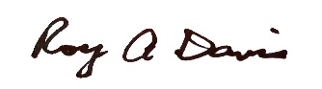
V/R

Roy A. Davis, Col (Ret), USAF
royadavis@yahoo.com
(253)549-2044

_____________________________________________________________________________________________

- PROOF OF SILVER STAR AWARDS

Pilot (Jensen) was bitter about not having his SS upgraded to a MOH. Does not want to send copy of SS proof. Telecons and news article state he received the SS.
The 374th’s commander in Vietnam, Andrew Iosue, who rose to the rank of four-star general, has been trying to get Jensen’s award upgraded to an Air Force Cross or Medal of Honor...” Stars and Stripes 2028.
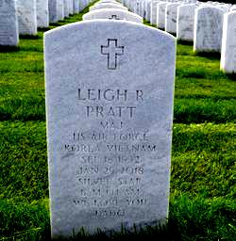
Copilot (Pratt) SS on grave marker.
I believe pilot and copilot were on separate orders (unavailable).
All other crew members are on orders below (Kirkpatrick, Kent. Bemis and Armistead.

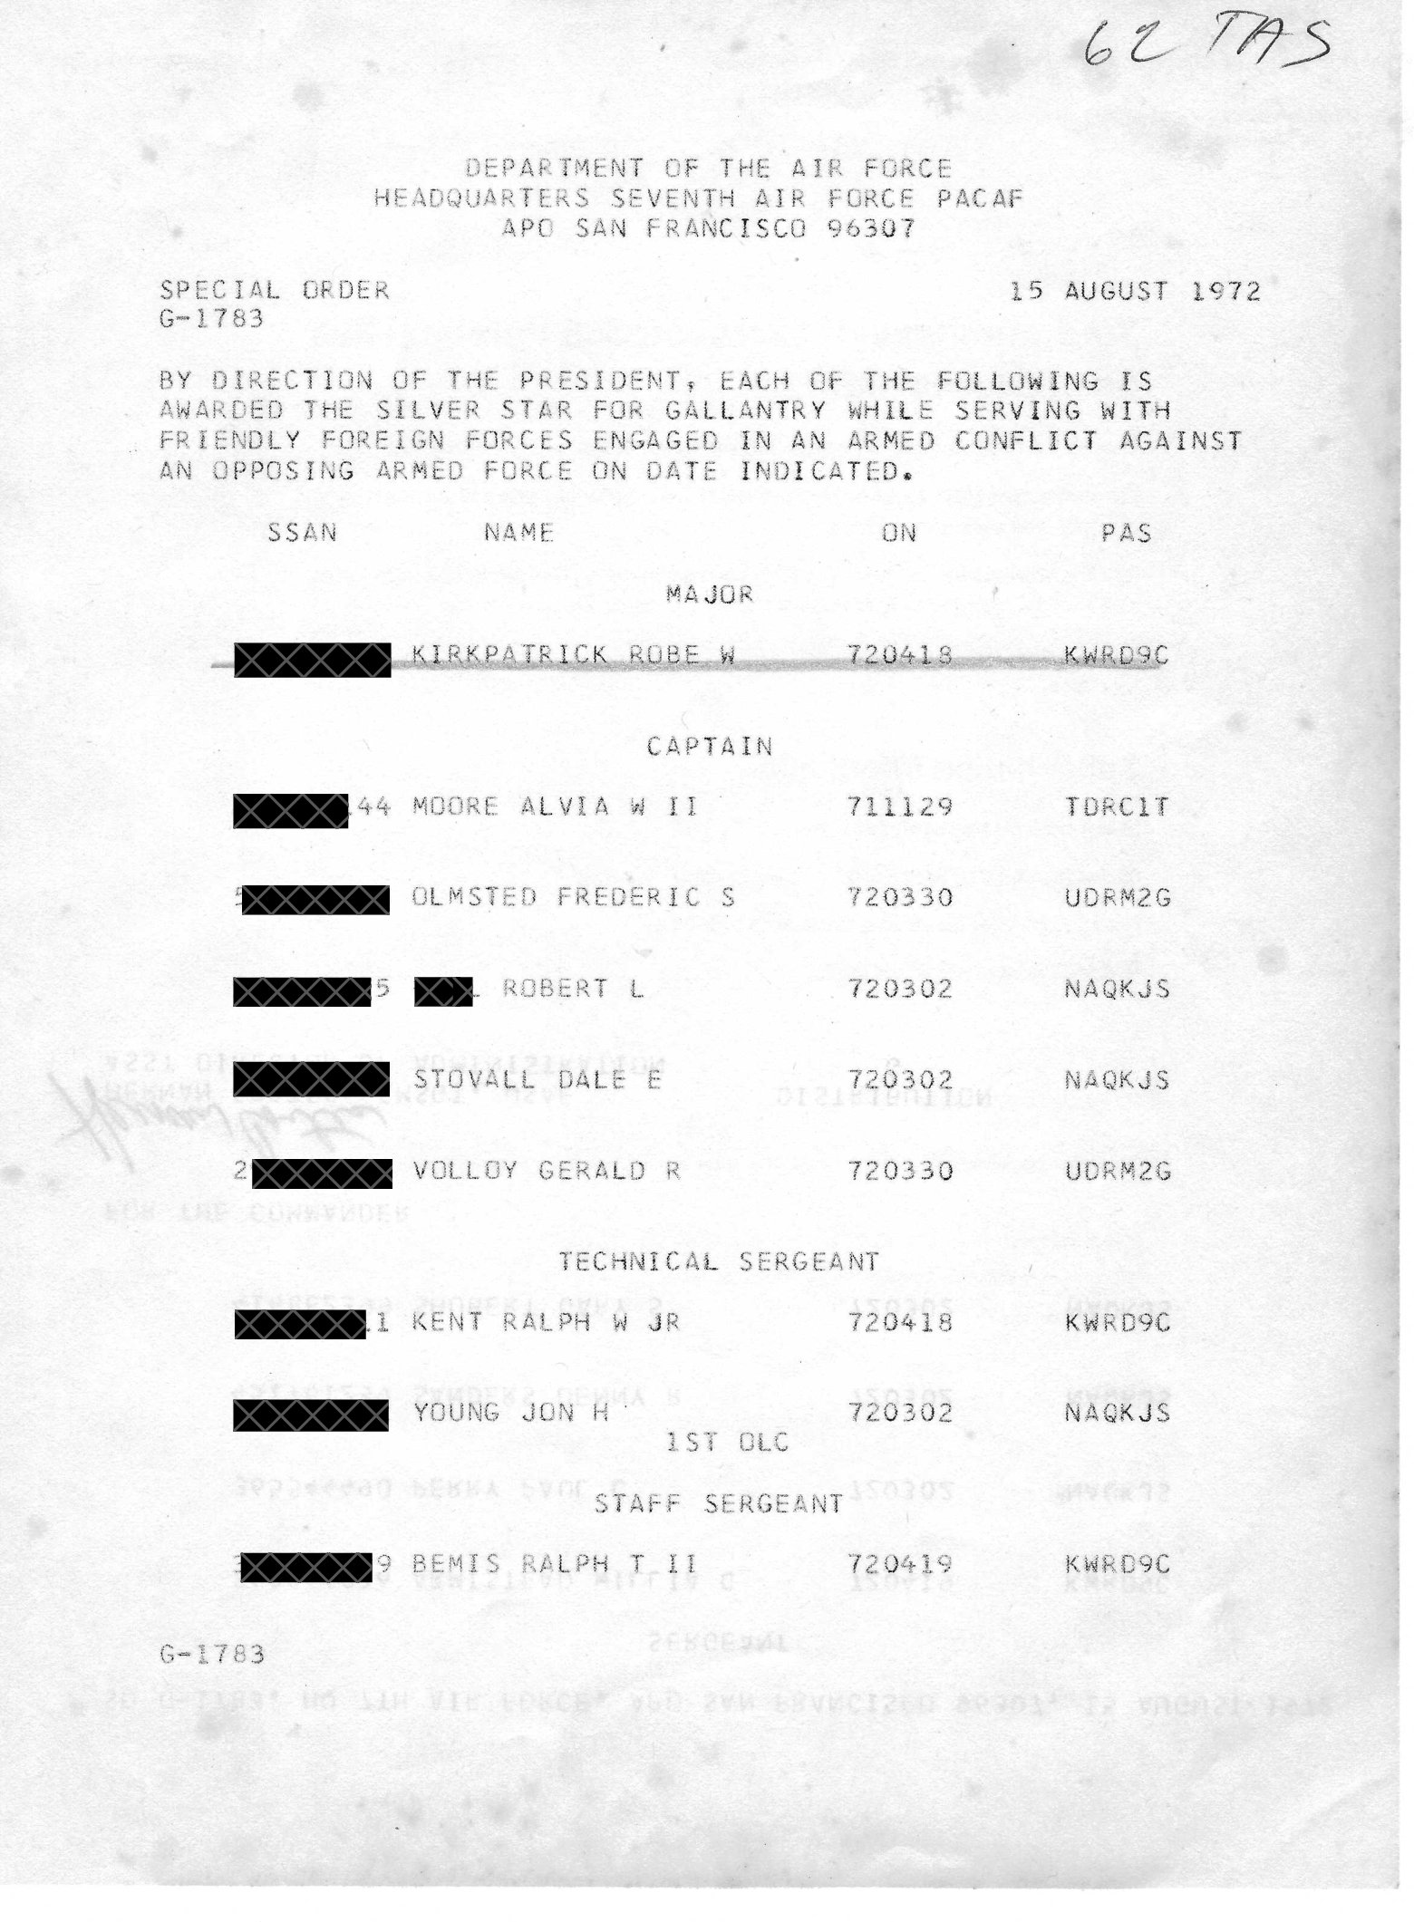
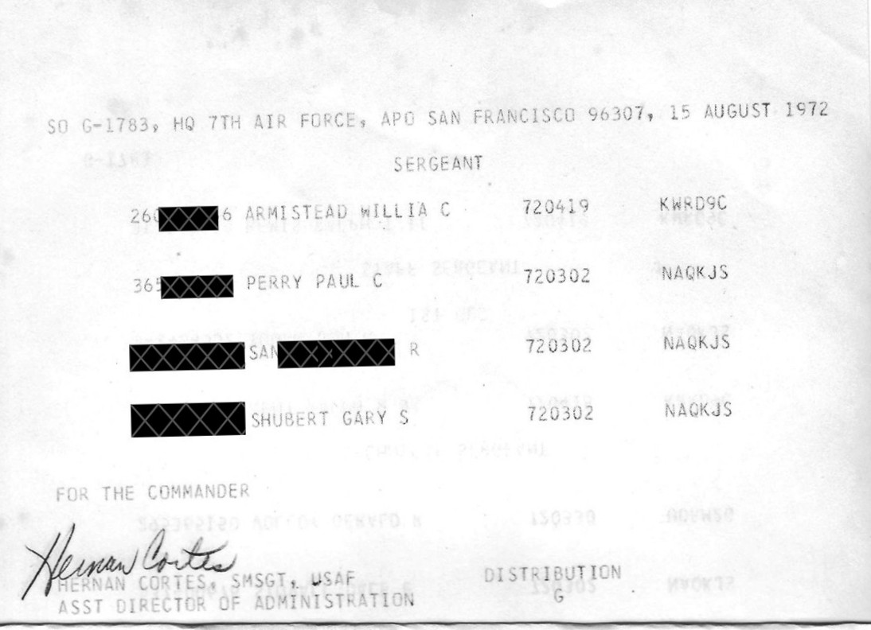

Sample citation and certificate for Manta 75.

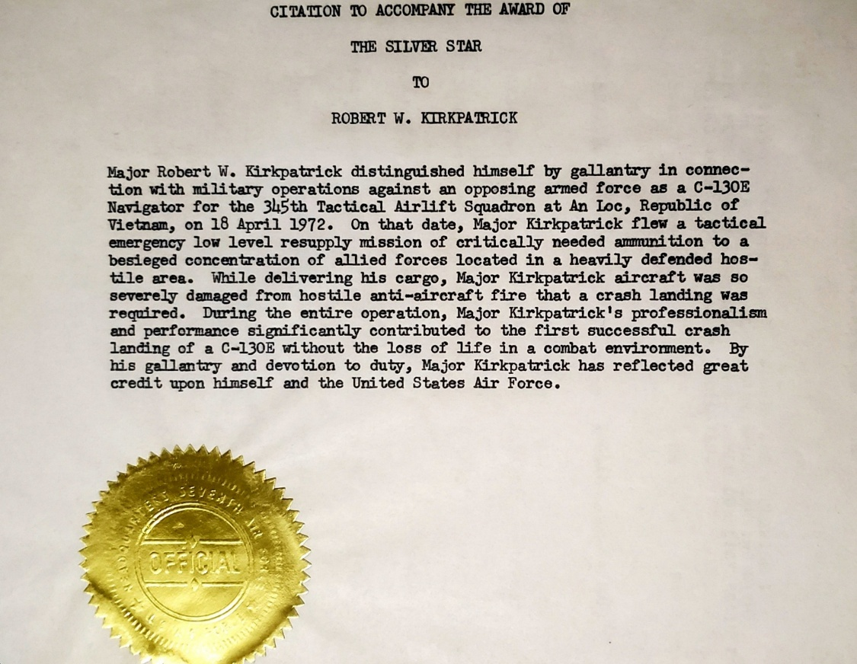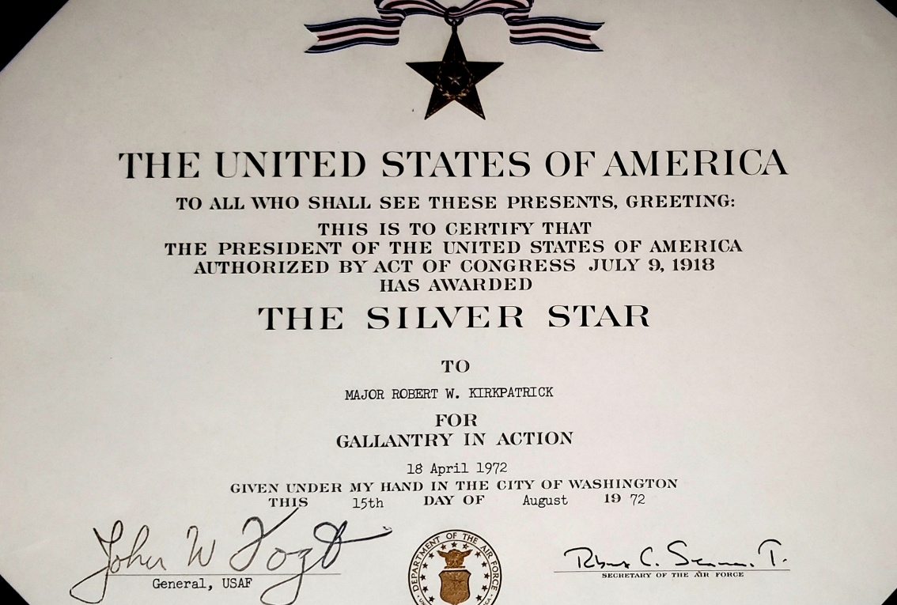

Sample certificate and citation for Cobra 32 (Army Huey gunship)
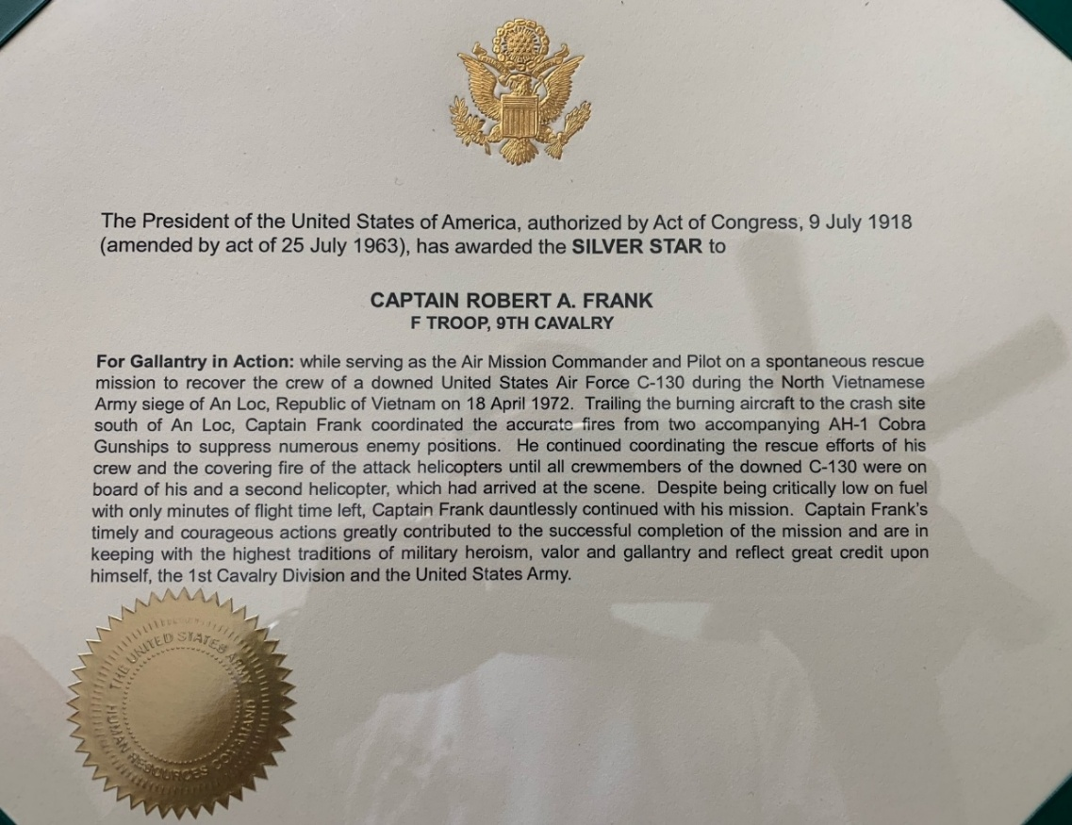
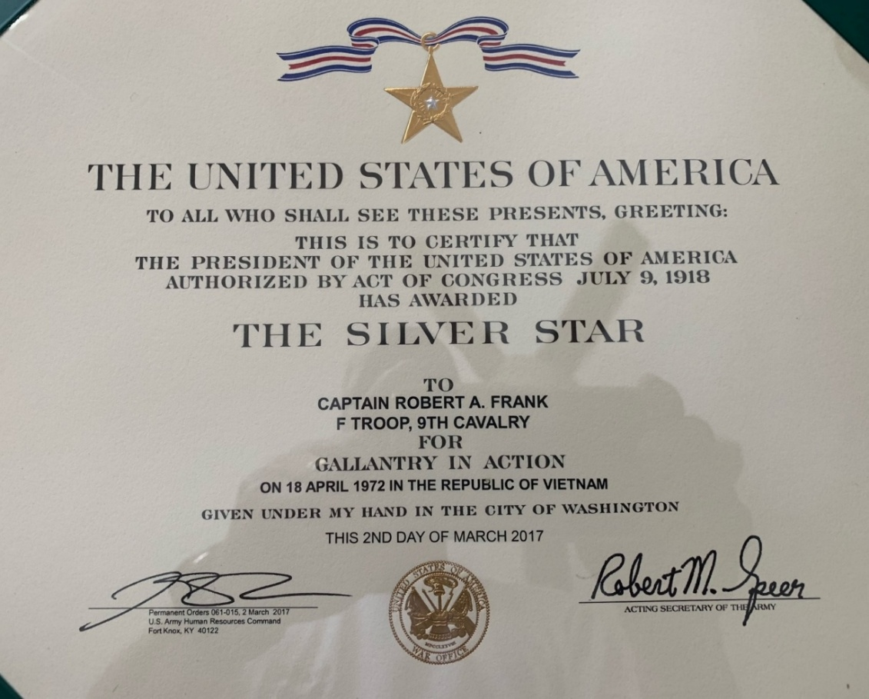
____________________________________________________________________________________
- CRAIG CORBETT (GUNNER) AFFIDAVIT

“The pilot and co-pilot where both using full left rudder and aileron control trying to keep the aircraft flying. The Flight Engineer was working with the pilots going through the emergency procedures to try and get the fire out and keep the aircraft airborne. The Navigator was calling MAYDAY and providing a safe bailout heading to the pilots. It was then the pilot ordered us to "Abandon aircraft!" The Lead Gunner had pushed the flare launcher out of the aircraft to allow the crew to bail out. The 10 was acting as jump master checking everyone over to ensure everyone was properly in parachutes as they abandoned the aircraft. Once eight crew members were out, the 10 would inform the pilot and exit the aircraft. Throughout this mission, the whole crew maintained exceptional crew coordination, ensured backup was available when and where needed and each crew member remained calm and professional. Each demonstrated gallantry under severe conditions and very accurate and deadly AAA. Everyone performed well during the emergency procedures and egress.”
____________________________________________________________________________
- JIMMY BARKALOW (COPILOT) AUDIO FROM VIDEO
“Everybody bailed out. Terry Courtney and I were flying the airplane as best we could with the drag and the lack of power. We were flying the airplane and finally he said, get out of here co(pilot). So, I ran to the back and jumped out and it was about 300 feet (above the ground). It's below when you're supposed to be able to make it. I pulled the D ring the second I exited the airplane and I hit the trees. Unfortunately, the chute didn't catch. It just deflated and lost its air. I went down about the last 30 or 40 feet banging against the trees and I had to get 50 stitches on my head.”
____________________________________________________________________________________

- LT GEN WASKOW (FAC/EYE WITNESS) AFFIDAVIT

“During my Intelligence prebriefing, I was surprised to hear that the 18th Special Operations Squadron's AC-119Ks that were deployed to Bien Hoa, were going to continue to fly daylight combat sorites over An Loc in one of the most lethal anti-aircraft environments in South Vietnam. Having flown multiple missions in the vulnerable 0-2A, the SUNDOG FACS had expressed concerns for the safety of the STINGER gunships and recommended that they be used after sunset only. “
“I am still surprised that the AC-119K's were fragged to fly daylight missions over the AAA environment above An Loc. As FACS, we were intimately familiar with the environment and used every asset at our disposal to support the ground commanders. We had assets available to use for Troops in Contact situations where the precise use of airpower was required. We recommended against repeated daylight exposure for the STINGER crews. It was inappropriate to expose a highly vulnerable combat asset such as the AC-119K to the daytime environment over An Loc. Yet these brave crews performed their tasks in an extraordinary manner. I fully support any further recognition that might be bestowed on these great American crew members. They truly performed above and beyond the call of duty on that day over the town of An Loc.”
____________________________________________________________________________________

- TOM MILLIGAN (FAC) AFFIDAVIT
“My first thoughts were that this was going to be a very dangerous mission, especially for the slow-moving AC-119 Gunship. Gunships were big targets and so they most often flew at night. To put this slow-moving gunship over An loc, one of the most dangerous places for aircraft in South Vietnam, during the day must mean that the target was of high importance.”
“Each survivor responded and followed my instructions in a most professional manner.”
____________________________________________________________________________________

- STINGER 41 AND MANTA 75 MISSION COMPARISON

COMPARISON WHICH MAY HAVE AN INPACT ON THE OUTCOME OF THE BOARD
(Very similar missions flown at the same time in the same area)
MANTA 75
- High value target in most heavily defended airspace in South Vietnam
  - Pallet of ammunition
- On !8 April 1972, C-130 Manta 75, was shot down by AAA over An Loc
- A right engine was hit and caught fire
- The crew struggled unsuccessfully to keep the aircraft flying
- The aircraft crash landed
- The was no loss of life for the seven crew members
- All six USAF crewmembers received the Silver Star in 1972

STINGER 41
- Two weeks later, on 2 May 1972, Stinger 41 was scheduled to destroy a high value target
  - Pallet of ammunition which landed short
- Crew accepted an extremely dangerous mission over the most heavily defended airspace in South Vietnam, An Loc
- This was a black gunship flying a rare daylight mission in an aircraft designed to fly at night
- They made several attempts to acquire the target while attempting to avoid AAA
- Stinger 41 was hit by AAA and the right engines were destroyed
- The crew struggled unsuccessfully to keep the aircraft airborne
- Three sacrificed their lives in the crash so their crewmembers could live
- Seven crew members successfully bailed out and were rescued from a hostile jungle environment

Another way to say it:
- Missions were within days of each other in the same hostile area
- Both high value ammunition pallets
- One mission to drop the pallet the other mission to destroy short drop
- Both aircraft hit by AAA in the right wing
- Both aircraft were not able to stay airborne
- Both crashed in hostile territory
- None died in one--three died in other to save others
- Both aircraft--survivors rescued
- One crew all were awarded Silver Stars (6)
- Other crew awards were downgraded (2) or denied (6)
These two missions are eerily similar. The crew members of Stinger 41, if adjudicated as they would have been in 1972 had their awards had not been lost, would most likely have received awards at the same level as Manta 75.
____________________________________________________________________________________

- VIETNAM MAGAZINE ARTICLE

HOW 9TH CAVALRY HUEYS SAVED A DOWNED CREW AT AN LOC
The crew of an Air Force C-130 transport plane had a narrow escape after they crashed near An Loc.
By THOMAS WARD 5/4/2022
Dr. Thomas Ward is an associate professor at the U.S. Command and General Staff College at Fort Leavenworth, Kansas.
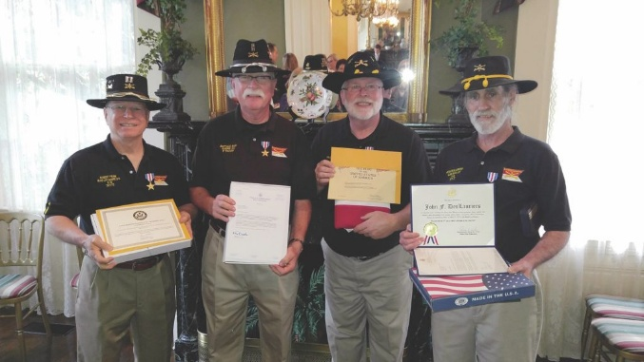
Manta 75 Rescue Helicopter Crew Cobra 32
Decades after the rescue of the downed C-130 crew at An Loc, Robert Frank and his Huey team received Silver Stars. The awards were presented on April 18, 2017, the 45th anniversary of the rescue, in Little Rock, Arkansas.
_____________________________________________________________________________

- STINGER 41 AWARD RECOMMENDATIONS
1Lt Jim R. Barkalow, Copilot (Deceased)
Recommended for the Silver Star
Award disapproved (2024)

Capt David R. Slagle, Navigator (KIA)
Recommended for the Distinguished Flying Cross w/Valor
Award downgraded to an Air Medal (2024)

SSgt Allen W. Bare, Flight Engineer (Deceased)
Recommended for the Distinguished Flying Cross w/Valor
Award disapproved (2024)

Lt Col Byron J. Taschioglou, Navigator/FLIR (Deceased)
Recommended for the Distinguished Flying Cross w/Valor
Award disapproved (2024)

1Lt Larry D. Barbee, Navigator/NOS
Recommended for the Distinguished Flying Cross w/Valor
Award disapproved (2024)

SSgt Francis J. Sledzinski, Lead Gunner
Recommended for the Distinguished Flying Cross w/Valor
Award disapproved (2024)

SSgt Delanor E. Iman, Gunner
Recommended for the Distinguished Flying Cross w/Valor
Award disapproved (2022)

A1C Richard C. Corbett, Gunner
Recommended for the Distinguished Flying Cross w/Valor
Award disapproved (2024)

SSgt Kenneth R. Brown, Illuminator Operator (KIA)
Recommended for the Silver Star
Downgraded to a Distinguished Flying Cross (2024)

