# April 6, 2021

From: Charles D. Pollock

Lieutenant Colonel, USAF, Retired

Subject: Missing Vietnam Distinguished Flying Cross for crew of Stinger 41, AC-119K Gunship

To: To Whom It May Concern

On March 30, 1972 the North Vietnamese invaded South Vietnam. They quickly drove south towards Saigon. The allies decided to make a stand at An Loc, a provincial capital not far north of Saigon. This was a bloody campaign with our Air Force having to do the heavy lifting due to the drawdown of American troops as we tried to extricate ourselves from South Vietnam.

On May 2, 1972 Stinger 41 was assigned to a daylight mission at Loc. Stinger gunships (AC-119K) were old and slow. A very effective aircraft at night for truck hunting down the Ho Chi Minh Trail and for close air support for friendly troops under attack. Flying low altitude in the daylight was not a mission it should have been used for. The crew demonstrated bravery and valor that day. Every man climbed on the doomed airplane to do their duty. Not a single crew member asked to be relieved.

Despite the conditions, including flying at a dangerous 3500 feet due to low clouds, the crew rolled in on the assigned target. They came under 37mm AAA attack almost immediately. They could not try to take evasive action because they could not see the tracers very well due it being daylight. After several orbits they were badly hit. They lost several feet of wing and an engine. The pilot and copilot heroically maintained enough control and with the efforts of the 10 (jump master) 7 crew members were able to bailout.

The entire crew distinguished themselves by extraordinary achievement in combat on May 2, 1972 at An Loc, South Vietnam. As Awards and Decorations Officer for the 18th Special Operations Squadron at the time of the Stinger 41 shoot down, it was my honor to submit the aircraft commander, Captain Courtney, for the Congressional Medal of Honor and the rest of the crew for The Distinguished Flying Cross. Captain Courtney was ultimately awarded the Air Force Cross. I coordinated the submissions with our squadron commander and our wing commander. I submitted the packages up the chain of command in August 1972 at Nakhon Phanom Royal Air Force Base. Thailand Crew members on Stinger 41 were:

Capt. Terence Courtney, KIA, Pilot (Awarded Air Force Cross.)

Lt. Jim Barkalow Co-pilot

Capt David Slagle, KIA. Navigator

SSgt. “Yogi” Bare Flight Engineer

Lt Col, “Tash” Taschioglou Forward looking infrared (FLIR) Operator

Lt. Larry Barbee Night observation scope (NOS) Operator

SSgt. “Ski” Sledzinski Lead Gunner

SSgt. Dale Iman Gunner

AIC Craig Corbett Gunner 

SSgt. Ken Brown, KIA, Illuminator (IO) Operator

It appears that these important awards got lost in the fog of war as we were closing out combat operations leading to our cease fire on January 27, 1975.

Please approve this award for the survivors and the families of our departed heroes.

Sincerely,

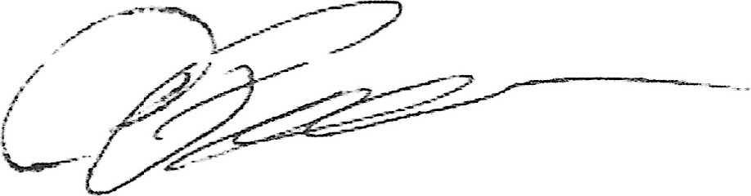

Charles D. Pollock

Lieutenant Colonel, USAF, Retired

[camppollock@icloud.com](mailto:camppollock@icloud.com)

704.575.4607

GSO 10B-41 NOTARIAL CERTIFICATE FOR

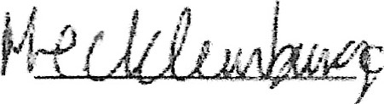County, North Carolina

I certify that the following person(s) personally appeared before me this day, each

acknowledging to me that he or she signed the foregoing document.



Name(s) of principal(s)

Date: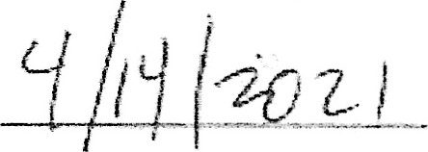

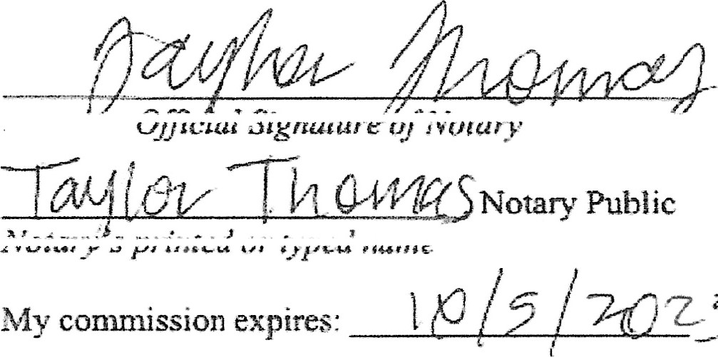

z5



(Official seal)

This certificate is attached to a