Statement Regarding Stinger 41 CSAR Mission, May 2, 1972, An Loc, Viet Nam

Submitted by Lamar C. Smith

On May 2, 1972 1 was a 1st Lieutenant USAF pilot assigned to the 1st Special Operations

Squadron, located at Nakhon Phanom, Thailand. Our unit equipment was the venerable A-I Skyraider which was perfectly suited to the special operations missions assigned to us and especially the combat search and rescue (CSAR) on-scene command role. We flew CSAR with the well-known Sandy tactical callsign. On this date I had been in country for 8 months and was both qualified as a Sandy lead and was experienced having directed several such CSAR efforts or portions thereof. Captain Dennis Morgan, my wingman, and I received the scramble order about 1450 hours as an AC-119 Gunship, call sign Stinger 41, had been shot down near the city of An Loc, about a 20-minute flight north of Bien Hoa. We were airborne in 10 minutes as were the 2 Jolly Green Giant rescue helicopters on alert at nearby Tan Son Nhut airbase. During the flight to An Loc, the aircraft commander of the lead Jolly Green and I conferred and received a briefing from the excellent forward air controller Sundog 29, I know now was Captain Tom Milligan. Sundog 29 was controlling the Stinger 41 fire mission, witnessed the fatal AAA hits and followed Stinger 41 west as it descended and the crew bailed out.

Upon arrival in the area and after a quick low altitude "tour" conducted by Sundog 29, I assumed on scene command. The first order of business was to assess the presence of enemy troops in the area. Here I trolled for enemy ground fire by presenting an overwhelmingly tempting target for them and with the canopy open, flying low and slow, they could not resist. In the cockpit I could hear the AK-47 reports and see the muzzle flashes. I found there were many enemy troops in various concentrations throughout the area of the now 6 survivors. One of the 7 survivors had already been picked up by an Army helicopter, but only one as the ground fire was too intense for additional attempts.

Each CSAR mission was fluid as you never knew how challenging the tactical situation would be. The challenges where 6 survivors not the usual one or two. Only two A-Is versus the usual 4 to protect the very vulnerable hovering Jolly Green. But the main challenge was the limited time before sunset, as we had zero night pickup capability. It was clear that if we did not recover all these survivors before night fall, they would invariably be located and captured or killed that night.

As my wingman and I used some of our soft ordnance to deliver against the 3-4 most obvious concentrations of enemy troops so as deny them freedom to search for the survivors, I discussed the dangers with the two Jolly Green Giant aircraft commanders. The risk to them was high, but they insisted we should make the recovery attempts under these circumstances. This courageous spirit on their part put into motion a critical requirement that all the moving parts would have to mesh precisely like gears in transmission. A major common denominator of this requirement was for the survivors to pay attention, communicate fully and efficiently, and to follow verbal direction from me and the Jolly Green crews precisely and instantly. The stress level was high for all involved, yet the 6 survivors could not have performed better.

Summary: On this day the crew of Stinger 41 showed great courage in going on the daylight mission, great courage in the face of withering ground fire in the An Loc area, great courage in the face of major battle damage to their plane, and great courage on the ground enabling their successful rescue before night fall. My observation of their cool performance in extreme danger is that each of them exhibited great courage and heroic action.

Signed: 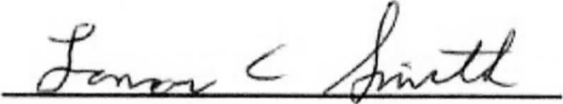 Date: 