Date:2 May 2021

From: Richard C. Corbett, CMSgt, USAF (Ret)

Subject: Purpose of this document is to describe the 2 May 1972 mission of an AC-119K gunship, tail # 826, call sign, Stinger 41, of the 18th Special Operations Squadron, 56th Special Operations Wing, Nakhon Phanom RTAFB

To: Whom It May Concern

Our mission was an urgent need requirement to fly from Bien Hoa Air Base, Republic of Vietnam (RVN) and provide daylight close air support to RVN forces and their US Advisors who were surrounded in the Provincial Capital of An Loc, some 60 miles north of Saigon and under direct attack by an estimated 30,000 North Vietnam troops supported by armor, artillery, infantry and anti aircraft defenses. The belief was if An Loc fell Saigon would be next.

A daylight mission minimizes the advantages of the AC-119K as the gunship is optimized to fly in hours of darkness in a steady orbit no higher than 6500 feet above ground level (AGL) and no lower than 2500 feet AGL where our six gatling guns were effective and on board sensors could better find targets, scanners could provide better Anti-Aircraft Artillery (AAA) evasive break calls and the black underside of the aircraft would afford better concealment. This knowledge along with reports from other Stinger crews who previously flew the early, daylight missions over An Loc of accurate AAA threat and at least one aircraft returning to base with possible battle damage concerned our crew.

We briefed that the more experienced gunners would scan since the AAA threat was high. Being the newest crew member, I would man the guns. We all discussed different mission aspects to ensure we had all possible concerns covered.

After takeoff, we proceeded to the target area but were told to hold short due the multiple aircraft on scene over An Loc. We used this time to bore sight guns and sensors which would ensure our systems were the most effective and thus less time exposed to AAA threats.

Once cleared into the target area, we joined up with an 0-2 forward air control (FAC) aircraft, Sundog 29, who would assist us locating targets. We entered the target area at 4700 feet AGL but the weather forced us down to 3500 feet AGL. The FAC brought us up on the radio with a US Army ground controller on scene, who directed us to target an enemy recoilless rifle. He stated marker panels were deployed to assist in target identification. The Night Observation Scope (NOS) Operator identified the area but there were no panels. While that was being rectified, we established an orbit to the east side of An Loc. Just then the Illuminator Operator (10) stated we were being shot at by 37mm AAA and he could not see tracers until it was too late to react but we could hear the rounds passing and could see the air bursts above. All scanners tried to determine where the guns were and continued to scan for tracers and muzzle fire. Each time the altitude changed, I would readjust the weapons for azimuth and elevation. When I wasn't changing the gun settings and 1st Lt Barbee was waiting on proper target identification, we were aiding the 10 in scanning for what was very accurate AAA.

The cloud layer above was dissipating so the pilots were able climb to 4500 feet AGL and still be able to acquire the targets but the AAA was still accurate and a second 37mm started firing at us. We could hear the shrapnel from the exploding rounds raining on the aircraft skin. We had made four orbits and the pilot told us we would make one more and if we could not find the gun or our target, we would exit the area and try another approach.

It was on this final orbit at when at least three rounds of 37mm AAA hit our right wing, wheel well and reciprocating engine. We could hear and feel it as the 10 stated we are hit and on fire. Our right jet engine also quit. Flames were trailing to the rear crew entrance door. With only the two left engines running, and the aircraft still on fire, the plane was fast becoming uncontrollable and losing altitude.

The pilot and co-pilot where both using full left rudder and aileron control trying to keep the aircraft flying. The Flight Engineer was working with the pilots going through the emergency procedures to try and get the fire out and keep the aircraft airborne. The Navigator was calling MAYDAY and providing a safe bailout heading to the pilots. It was then the pilot ordered us to "Abandon aircraft!" The Lead Gunner had pushed the flare launcher out of the aircraft to allow the crew to bail out. The 10 was acting as jump master checking everyone over to ensure everyone was properly in parachutes as they abandoned the aircraft. Once eight crew members were out, the 10 would inform the pilot and exit the aircraft. Throughout this mission, the whole crew maintained exceptional crew coordination, ensured backup was available when and where needed and each crew member remained calm and professional. Each demonstrated gallantry under severe conditions and very accurate and deadly AAA. Everyone performed well during the emergency procedures and egress.

When we bailed out, Sundog 29 immediately became on scene commander and started search and rescue (SAR) of survivors. Suddenly, US Army helicopters made a pass overhead firing rockets and machine guns. Unnerving, but they were attempting to rescue our lead gunner who was being shot at by a machine gun very close to his landing position.

We started checking in and vectoring the Sundog 29 over our positions. I saw two enemy running past me. Shortly afterwards two A-IH Sandy aircraft arrived. Sundog showed Sandy our positions and Sandy made some low, slow passes to draw fire. They laid down smoke and asked Stinger 41 Delta and India to flash them with mirrors. Delta radioed the sun was too low and the light too poor for mirrors to be effective.

Sandy then asked Stinger 41 Alpha to come up on radio. When Alpha did not come up Sandy asked for the Stinger closest to the wreckage to come up. Sandy stated no one was coming up on the radio and asked any Stinger come up on radio. That led to several Stingers coming up simultaneously. Sandy reverted to the alphabet and called for Bravo to 'pop smoke' which the Co-Pilot did. All calls after that were for the next closest to 'pop smoke' until all survivors were on the two HH-3 Jolly Green aircraft. It took four and a half hours from the time we were hit till all were picked up. I was the last survivor hoisted to safety as night had closed in four and a half hours after shoot down.

The SAR team complemented the crew on the coordination and discipline during the SAR and said it was the smoothest multi-crew SAR they had seen. We assist in a smooth and rapid extraction. This was also the largest and most successful SAR operation in Southeast Asia (SEA). This Stinger 41 was the last daylight gunship mission. Sadly, we lost three comrades all of whom were true professionals.

Richard 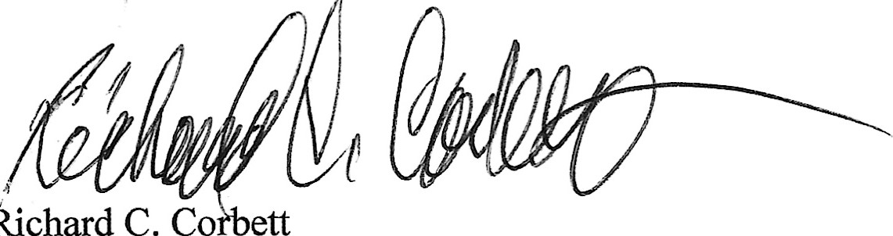

CMSgt, USAF (Ret)

