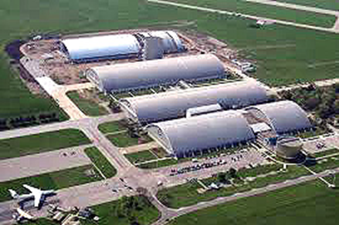  National Museum of the USAF  Memorial Park  Wright-Patterson AFB, Dayton, OH  AC-119 Gunship Association  Reunion XVIII Sept. 29, 2017  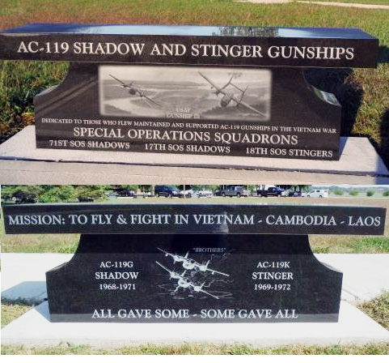 | 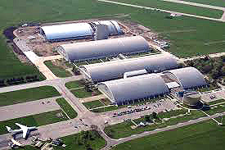  National Museum of the USAF  Memorial Park  Wright-Patterson AFB, Dayton, OH  AC-119 Gunship Association  Reunion XVIII Sept. 29, 2017 | National Museum of the USAF  Memorial Park  Wright-Patterson AFB, Dayton, OH  AC-119 Gunship Association  Reunion XVIII Sept. 29, 2017
Program Outline    Welcome – Mike Drzyzga,  Association President  Presentation of Colors  Pledge of Allegiance  Invocation Larry Hunter,  Association Chaplain  Roll Call: 17th SOS Larry Fletcher  18th SOS Robert LaRosa  Taps  Memorial Bench Commemoration  L. Fletcher  Dismissal – M. Drzyzga  Benediction – L. Hunter  Photo Op – walk to visit the Memorial Bench | Program Outline  Welcome – Mike Drzyzga,  Association President  Presentation of Colors  Pledge of Allegiance  Invocation Larry Hunter,  Association Chaplain  Roll Call: 17th SOS Larry Fletcher  18th SOS Robert LaRosa  Taps  Memorial Bench Commemoration  L. Fletcher  Dismissal – M. Drzyzga  Benediction – L. Hunter  Photo Op – walk to visit the Memorial Bench | Program Outline  Welcome – Mike Drzyzga,  Association President  Presentation of Colors  Pledge of Allegiance  Invocation Larry Hunter,  Association Chaplain  Roll Call: 17th SOS Larry Fletcher  18th SOS Robert LaRosa  Taps  Memorial Bench Commemoration  L. Fletcher  Dismissal – M. Drzyzga  Benediction – L. Hunter  Photo Op – walk to visit the Memorial Bench

