Please reserve your seat by signing up. If you don’t sign-up ahead of time here, you only get to sit in a seat that is not already reserved by someone who DID sign-up.
Baby Huey will tactfully ask you to move if you try to sit where someone already signed up & reserved that seat. If tact doesn’t work, he’ll throw your sorry ass out!
Not really ………, but do you get the message? If you don’t sign up, YOU get leftover seating. Please sign up by individual names – not just “Fred Pismo’s Table.”
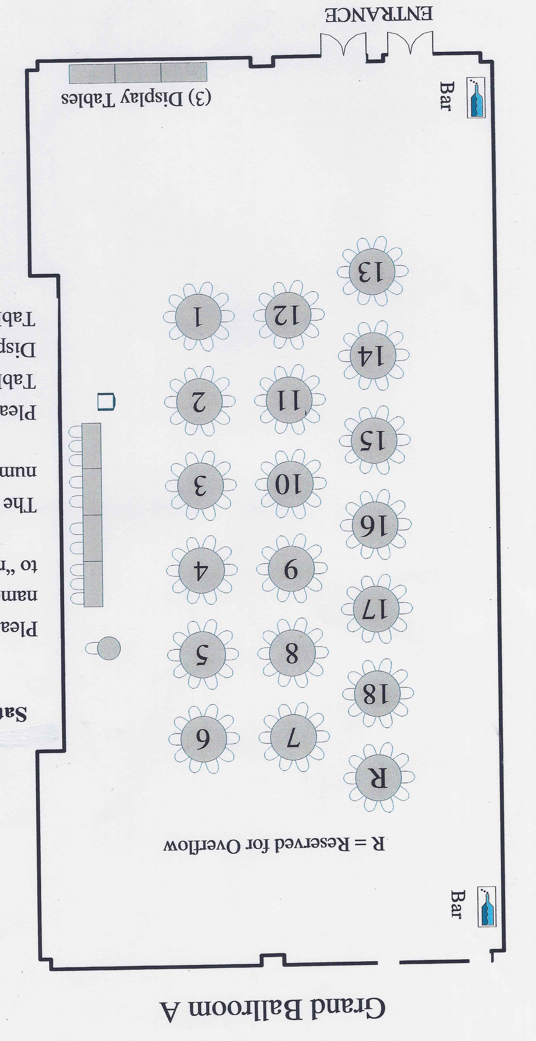

Table 1: | Table 2: | Table 3: | Table 4:
Table 5: | Table 6: | Table 7: | Table 8:
Table 9: | Table 10: | Table 11: | Table 12:

Table 13: | Table 14: | Table 15: | Table 16:
Table 17: | Table 18: | Table 19: | Table 20:

