
Certificate of Appreciation

This Certificate is presented to:
Tyler Augustis Vaughn
For his energy, time, and commitment to helping the Association Quartermaster, Gus Sininger, fulfil orders.
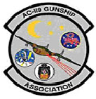 | __________________________________________  Michael J. Drzyzga  President, AC-119 Gunship Association  June 15, 2022

