
Certificate of Appreciation

This Certificate is presented to:
Vern Gwin
For selflessly creating two very-special Stinger (Scorpion) models and a plaque for presentation to the 18th Special Operation Test Evaluation Squadron, Hurlburt AFB, Florida
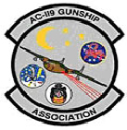 | __________________________________________  Michael J. Drzyzga  President, AC-119 Gunship Association  February 24, 2022

