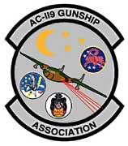 | 
2020 Association Board

President
Jerry Hester

Vice President
Roy Davis

Secretary
Andrea Drzyxga

Treasurer
Doug Wohlgamuth

Past President
Michael Drzyzga

Member at Large
James Dunn
Jenna Laird
John Wolff

A Non-Profit Association
Of AC-119 Gunship
Air and Ground Crew
and Families.

