AC-119 Gunship Association  DUTY, HONOR, COUNTRY  “Fortifying the Brotherhood”  Bozeman, Montana  Mike Mullen  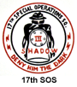  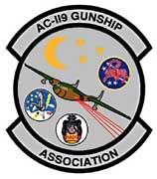  ‘AG’ 69-70  17th SOS |  | AC-119 Gunship Association  DUTY, HONOR, COUNTRY  “Fortifying the Brotherhood”  Bozeman, Montana  Theresa Mullen  Gunner Spouse  17th SOS
AC-119 Gunship Association  DUTY, HONOR, COUNTRY  “Fortifying the Brotherhood”  Vietnam, Cambodia, Laos, Thailand  Steve MacIsaac  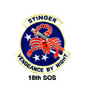  Pilot 71-72  18th SOS |  | AC-119 Gunship Association  DUTY, HONOR, COUNTRY  “Fortifying the Brotherhood”  Vietnam, Cambodia, Laos, Thailand  Nancy MacIsaac  Pilot Spouse  18th SOS
AC-119 Gunship Association
DUTY, HONOR, COUNTRY
“Fortifying the Brotherhood”
Vietnam, Cambodia, Laos, Thailand
Bill Hanson

Maintenance
18th SOS

