**June 1, 2020 FLASH**



Greetings AC-119ers:

We need copies of your special orders, including Air Medals, DFCs, Purple Hearts, Air Crew badges, PCS Orders, TDY Orders, etc - include Amendments, Also, we need your DD-214s.

Why? When you look at those orders, you often see many names besides yours. These other people may be looking for the orders that you have, to file a claim or to amend their DD-214; or their family may need these orders for burial purposes or to file claims for themselves.

Please send the orders to Ev Sprous so he can enter them into the spreadsheet he is working on. Ev is working with Col Mac to get the orders digitized. Eventually, we will work to get the orders on the Association Web Site. SS#’s will always be hidden on any orders that are sent out to individuals. Ron Julian also uses the spreadsheet to update the AC-119 Gunship Rosters. Please do not send your original orders. Make copies or scan your orders and snail mail them to: Everett Sprous, 2615 N Columbus Blvd, Tucson AZ 85712-1937.

Please help your brothers in arms with their claims and also searching for our lost brothers. Also, if you are looking for copies of orders, let Ev or Col Mac know and we will get you a copy.

The following Agent Orange Update article is from Col Mac: All Air Bases in Thailand have been added to the Agent Orange list (AO was used to spray around all base security zones).

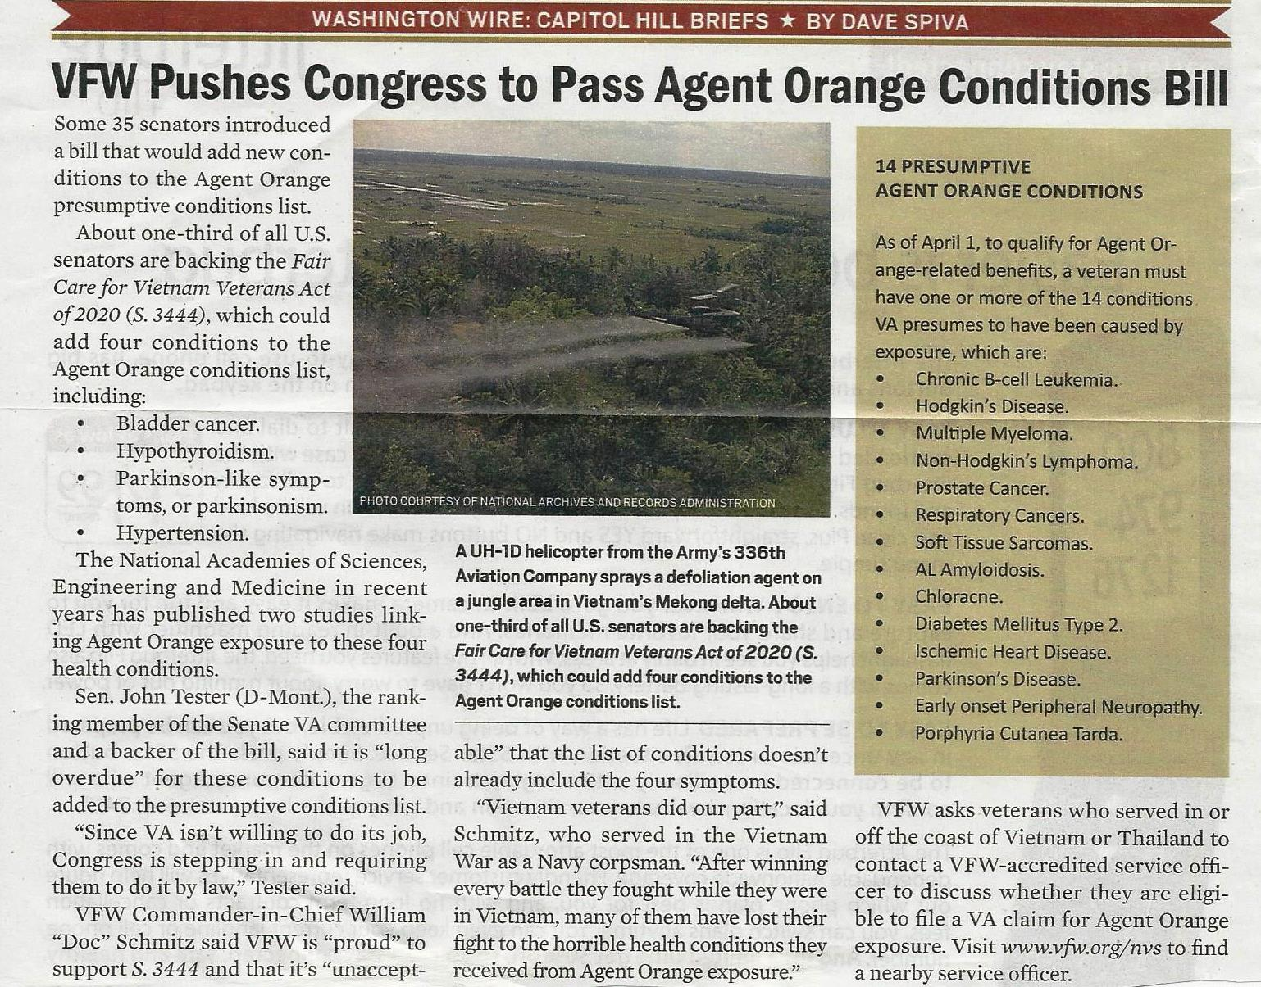

We want you to be a member of the AC-119 Gunship Association.

By becoming a paying member, you help the Association with Newsletter and other costs. The membership application is below. Sign up your wives, children and grandchildren. They will help us carry on our legacy



AC-119 Gunship Association

Membership Application

*(Application or Renewal)*

I hereby apply for membership in the AC-119 Gunship Association. I understand my membership is for the sole purpose of supporting and promoting the history, heritage, traditions, and legacy of the AC-119 Gunship Program and its operations in Southeast Asia. I understand that my Membership is NOT to be used to support or endorse any personal, political, or commercial activity unless it directly supports the AC-119 Gunship Program and is specifically authorized by the Association’s Board of Directors.

Membership: New Member _________Renewal __________ Annual _______ Life _______

Name (First, M, Last): __________________________________________________________

Mailing Address: ______________________________________________________________

City: _________________________________State: _______________ Zip: ______________

Phone (home/cell): ______________________________E-Mail: _______________________

***Select EITHER Regular or Associate Membership:***

1. ***REGULAR Membership****:*

__ I served in combat or directly supported the marked units (check all that apply):

__ 71st SOS __ 17th SOS __ 18th SOS Aircrew/Ground Support Position: ____________________

Duty Station(s) & Dates: _______________________________________________________________

1. ***ASSOCIATE Membership:***

__ I am related to the following individual who served in or directly supported the AC-119 missions:

Name of AC-119 Relative: ____________________________, how related: ______________________

__ I will promote the history, heritage, traditions, and legacy of the AC-119 Gunship Programs

Applicant’s Signature: ______________________________________ Date: ______________________

If you have a PayPal account, you can send your dues as follows:

1. Open your PayPal Account Click on the "Send" icon (upper right). In the "Send money to" box, enter Treasurer Doug Wohlgamuth’s email (dawohlgamuth@gmail.com). Click "Next" button and enter the dollar amount. Add a note describing the payment (Annual or Life Membership). Click "Continue” and choose the payment method (PayPal account or Credit Card).Verify summary that all info is correct.

OR;

1. Write a Check or Money Order (made payable to AC-119 Gunship Association) as a $20 donation for Annual Membership dues, or a $119 donation for Lifetime Membership. If paying using this method, Mail this completed form with your Check or Money Order to: Everett Sprous, 2615 N Columbus Blvd, Tucson, AZ 85712-1937. Questions: email Ev at [ac119kstingergunner@gmail.com](mailto:ac119kstingergunner@gmail.com)Or call 520-528-9444

This section is for the Membership Coordinator:

LIFE # _______ Annual Expiration Date: _________ Original Join Date: _______

Membership __ Approved or __ Denied by the __ Membership Coordinator

On Date: Membership Coordinator’s Signature:

**Reunion Photo Request from Past Reunions for Project**

**by Andrea Drzyzga**

Hello all AC-119er’s,

I need your help. I’m working on a little project and I am looking for pictures from past reunions. Table Pictures at the Saturday night Banquets are especially sought after, candid pictures and fond memories of those who are no longer with us. We will accept photographs or digital pictures. Each picture MUST have the NAMES OF INDIVIDUALS in that picture, and please include the REUNION YEAR.

You can send photographs or digital pictures to Andrea Drzyzga 37 Pecan Lane, Oak Ridge, NJ 0438 or email secretaryAC119@optonline.net. I will return your photographs!!

Please only send 1-3 of your best photos. We are looking for good representation of our 20 years of reunions! We will sort through as many as we can; we may not be able to use all that we receive during one particular year.

**Another photo project has been started**

**by Lloyd Froelich.**

Floyd would like photos from our time in the gunships. Please only send photos that you can name the person(s) in the photo. Floyd will work to put together an album of our guys. Send to [lloydfroelich@icloud.com](mailto:lloydfroelich@icloud.com).

Stay safe and we will see you next year in Ft Walton Beach, FL for the 2021 Reunion.