ROY A. DAVIS, PILOT
18TH SOS AND 17TH SOS, PHAN RANG, 1969-1970
THE BEGINNING I was born in Queens, New York, in 1942. I went on to get my degree in Meteorology at Florida State University. In 1966 I got my commission through OTS and my first assignment was pilot training at Craig AFB, Alabama. After graduating from UPT as the top pilot in the class, I went to the 8th MAS at McChord AFB, Washington, to fly the C-141
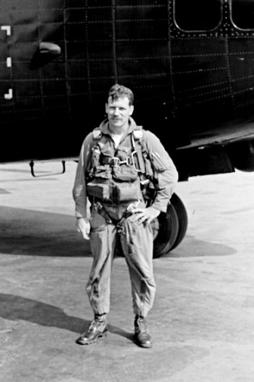
AC-119G AND K In January 1969 I was assigned to fly the AC-119K gunship at Phan Rang AB in Vietnam. Training was to be three months long. Initial training was in the C-119 at Clinton County Airport, Ohio, by reserve pilots. After completing this training, gunship training was started at Lockbourne AFB, Ohio. I can remember my first live fire mission over Lake Erie. I was in the cargo compartment waiting my turn sit in the left seat. I swore that I could hear the guns firing—wrong. When the minis started to fire the noise was startling and deafening. Training was completed around the end of June. The only problem was the crews were ready but the 18 aircraft we were supposed to ferry to Vietnam were not. Departure was rescheduled for October, November, and December 1969. My aircraft was scheduled along with five others for December. From April to December there was not much to do other than remain current in the aircraft. We departed in late December and spent the first two nights at Malmstrom AFB, Montana, and McChord AFB, Washington. At Malmstrom we had to have our right J-85 jet engine replaced. We had to take the longer northern route because the aircraft did not have enough fuel to make it from California to Hawaii.
On Dec 31, 1969 we left McChord for Alaska. Our one year tour started as soon as we left the CONUS. I spent the first day of my Vietnam tour snow skiing at the Alyeska ski area in Anchorage, Alaska. Our next stop was at the naval station on Adak Island in the Aleutian chain. Alaska king crabs were in season and we got to visit a commercial crab boat and left with a large green plastic bag filled with pure crab meat—delicious.
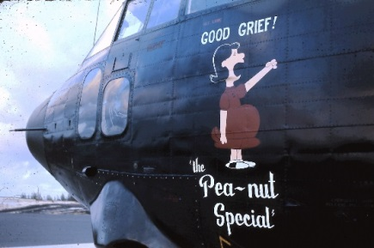
Next we headed south to Midway Island. The weather on this route was terrible—low clouds and huge thunderstorms in freezing temperatures. The other aircraft in our flight, Capt Dick Twaddle was the a/c, called and said they lost their weather radar and could they use their FM homing radio to home in on us and thereby avoid the thunderstorms. A short time later they called asked us what the f%# we were doing. They said they were flying into every thunderstorm on the route and were icing up to the point where they could no longer maintain altitude. We finally figured out that the FM homing device preferred thunderstorms to our FM radio—close call for them.
We arrived at Midway at the height of black albatross mating season. Quite a sight to see these large birds doing their mating dance. It was on Midway that a naval NCO offered to paint nose art on our airplanes. He did an awesome job painting the following on our aircraft: Lucy’s “The Pea-Nut Special” (my aircraft), “Fly United” (Twaddle), “The Polish Cannon” (Kwiecinski), and “The Super Sow”. Unfortunately this artwork was removed after arriving at Phan Rang.
The next stops after Midway was Wake Island, followed by Guam, Clark AB and finally Phan Rang AB. The trip took almost a month. The first thing we did was head right back to Clark AB to attend Jungle Survival school. This was not a fun course. We were let loose in the jungle and had to escape, evade and survive. The area we were in was infested with rats. During the night you could feel them running across your body.
Upon returning to Phan Rang I received my in-country flight check and began to fly combat missions. Upgrade to aircraft commander was based on date of rank, so in order to upgrade more quickly I transferred from the 18th SOS to the 17th SOS. Shortly after the move I upgraded to aircraft commander.
The majority of the missions we flew were in support of ground troops in contact with the enemy (TICs). In addition we periodically sat alert in the event we needed to respond rapidly. Most of the combat missions we flew were at night.
During the day we had time for some recreation after getting some sleep. I was interested in photography and the base conveniently had a photo lab. I also played handball and tennis with Dan Eramo and Joe Crocco.
Flying TIC missions was less stressful and dangerous than truck hunting over the Ho Chi Minh trail. I had only one in flight emergency. On a mission over Cambodia we had a runaway prop. The RPM was controllable and the prop blades ran away against the stops. We turned around and headed towards our emergency field, Pleiku AB. The only issue was a discussion I had with the copilot and engineer on what the proper procedure was for our emergency. They wanted to shut the engine down when I knew the proper procedure was to increase the RPM to 3100 to be able to provide some torque from that engine. Weather was not great at Pleiku but we made a successful emergency landing.
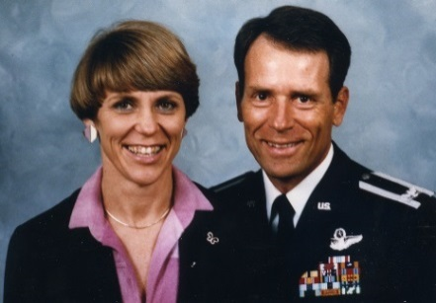
AFTER GUNSHIPS In late September 1970 I was given a compassionate reassignment to McChord AFB to fly C-141s. This reassignment was due to a serious illness in my wife’s family. I was assigned to my old squadron, the 8th MAS. I upgraded to flight examiner as then reassigned to the 62nd MAW as a stan eval flight examiner. In 1977 I applied for and was selected to fly the VC-137 for the 89th MAW at Andrews AFB. Due to a reduction in Presidential airlift by President Carter, my assignment was changed to the VC-135 at Ramstein AB, Germany. After two years of flying Gen Alexander Haig, I was reassigned to Det 1, 89th MAW at Hickam AFB to fly the VC-135 and be the Det Ops Officer. This assignment was followed by a year at CINPAC protocol; command of the AFROTC unit at Montana State University in Bozeman, MT; Chief of Staff at HQ AFROTC; and finally the AFROTC NW Regional commander.
I retired as a Colonel in 1992 where I became a firefighter for the City of Tacoma. Now, retired for a second time, I live with my wife, Paula, in Peoria, Arizona.

